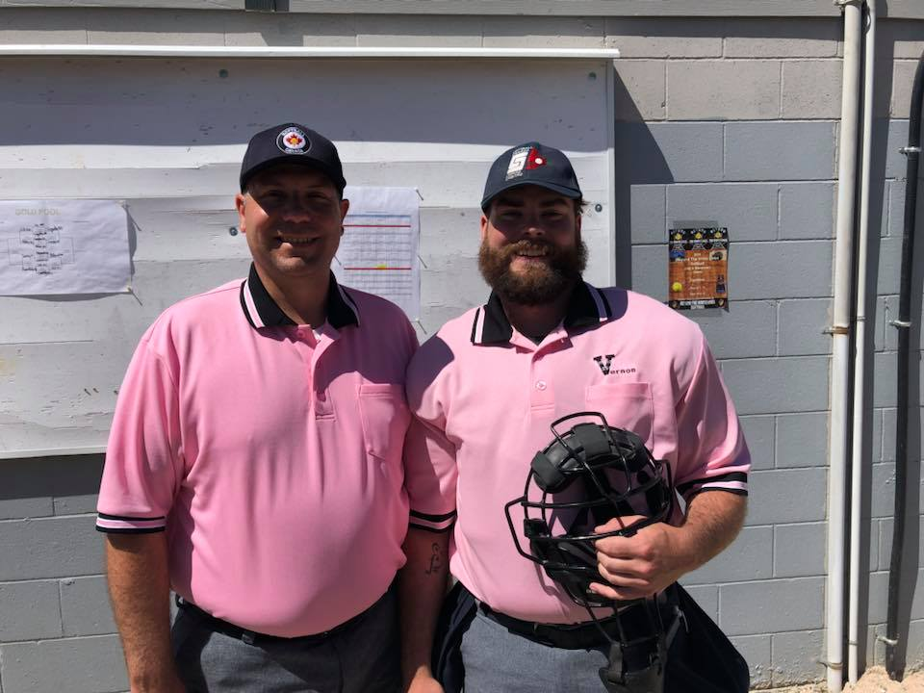
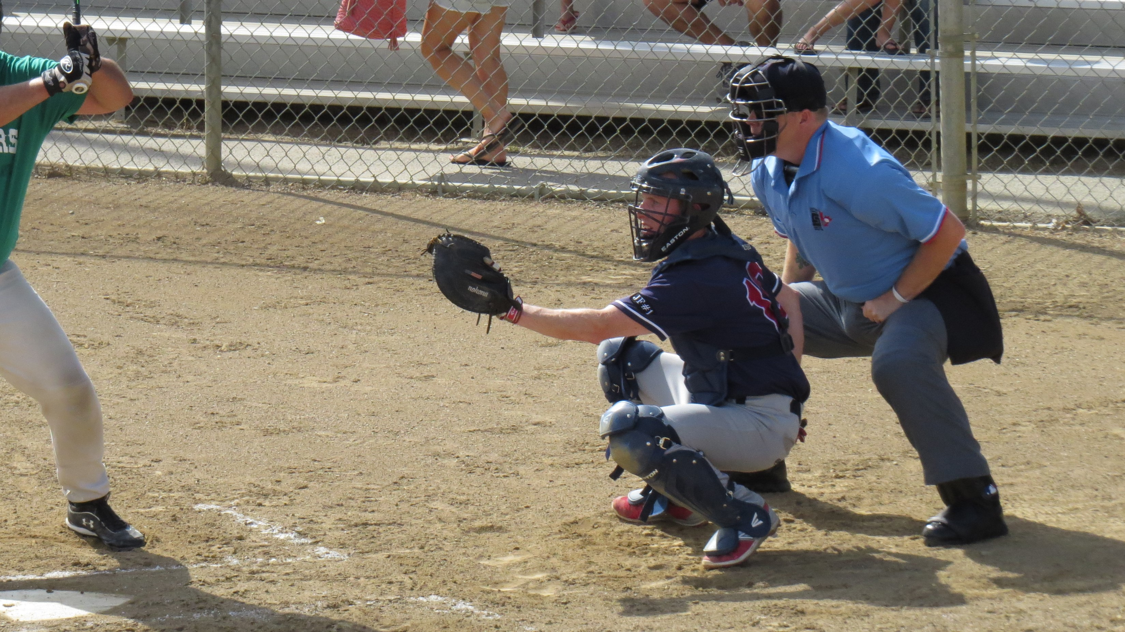

OKANAGAN VALLEY DISTRICT 9 FASTPITCH IS LOOKING FOR YOU!

District 9 is actively recruiting people of all ages (youth to adult) who might have an interest in becoming an umpire for the 2021 Fastball season. No experience necessary. Attend an information clinic to find out what it is all about.

Great benefits include:

- Free 1st year registration and training (with a mentorship program to help you develop your skills)
- Learn new rules, meet new friends and make new money! All while having fun at the ballpark
- Training and mentorship from skilled Umpires to help make umpiring a life-long opportunity for you
- High school students can earn up to four high school credits towards graduation

Information clinics will be held in your community this winter running January through March.
For further details contact Brad Snyder (Umpire In Chief) d9umpireinchief@softball.bc.ca

